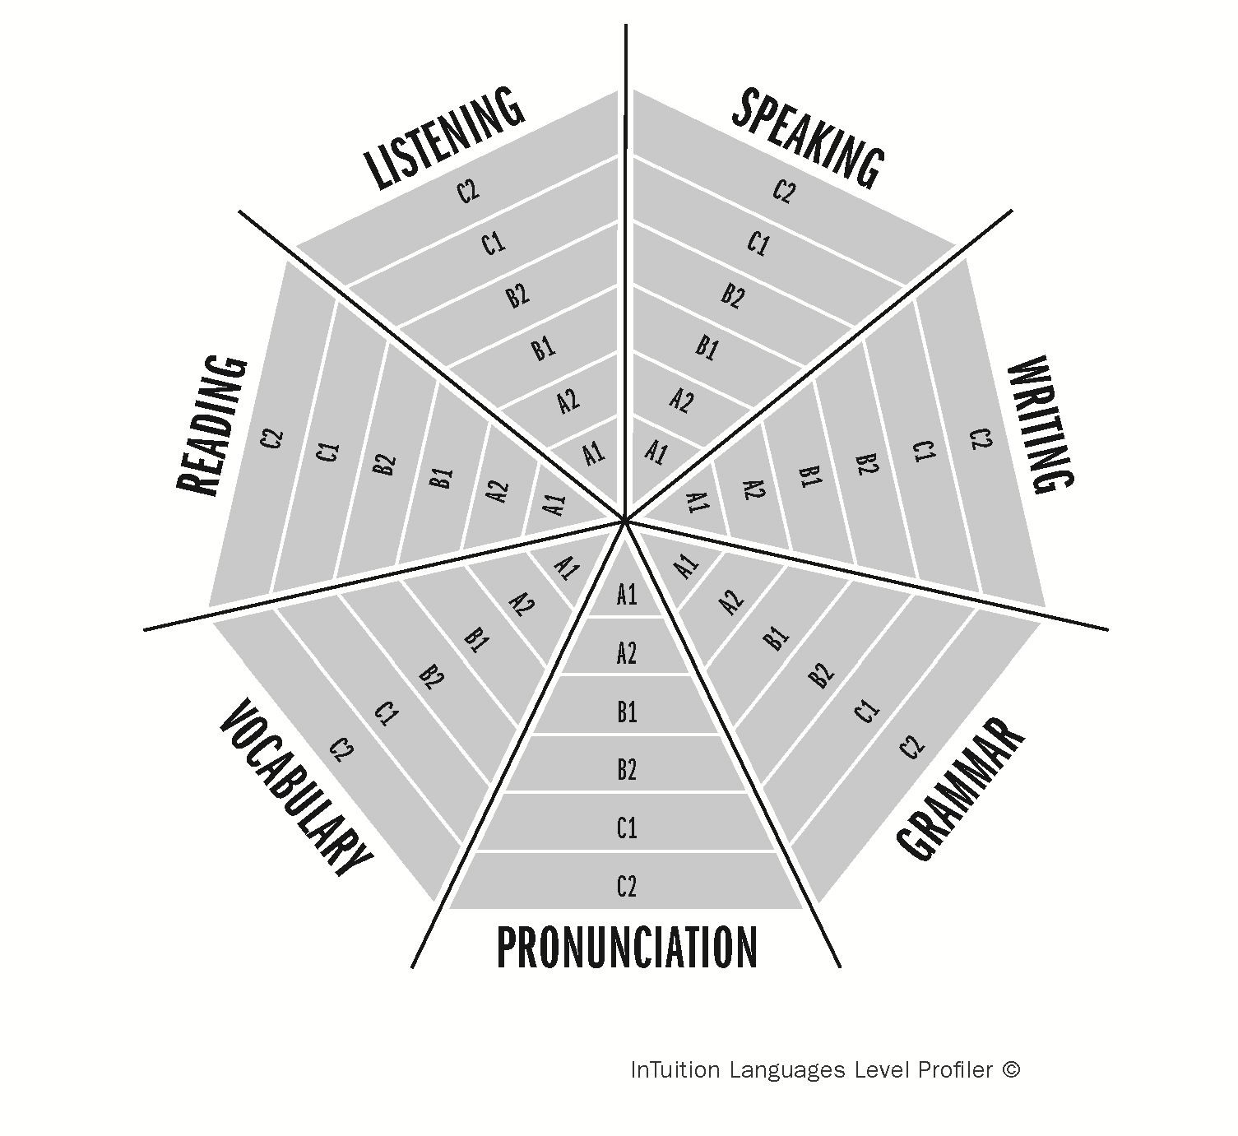**InTuition Languages Level Profiler ©**

**Student:**

**Date of Assessment:**